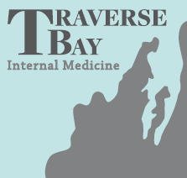
Prescription Update!
Please be sure when picking up free & discounted prescriptions
from the pharmacy that you are requesting that the
pharmacy send a $0.00 claim to your insurance.
Thank you!
TBIM Physician’s & Staff

Prescription Update!
Please be sure when picking up free & discounted prescriptions
from the pharmacy that you are requesting that the
pharmacy send a $0.00 claim to your insurance.
Thank you!
TBIM Physician’s & Staff

Prescription Update!
Please be sure when picking up free & discounted prescriptions
from the pharmacy that you are requesting that the
pharmacy send a $0.00 claim to your insurance.
Thank you!
TBIM Physician’s & Staff

