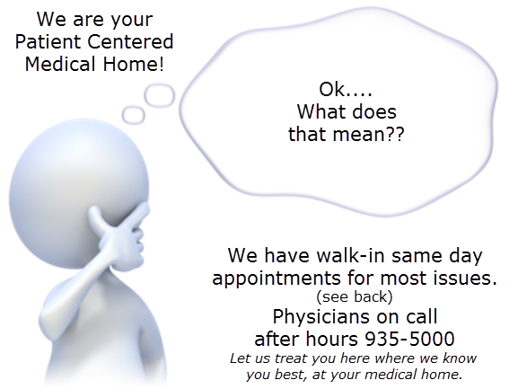 |  |  | 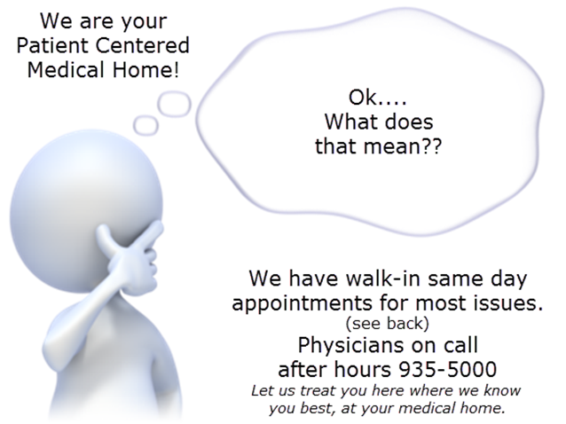

 | Illnesses such as:  Ear Pain  Sore Throat  Cough or Congestion  Sinus Issues  Burning when you pee  Rash or Bug bites  Cuts or splinters  Possible broken bone  Pink Eye  Tooth Aches  Hurt your back (not long term back pain)  Nausea and Vomiting  Migraines or Headaches |  |  |  | Illnesses such as:  Ear Pain  Sore Throat  Cough or Congestion  Sinus Issues  Burning when you pee  Rash or Bug bites  Cuts or splinters  Possible broken bone  Pink Eye  Tooth Aches  Hurt your back (not long term back pain)  Nausea and Vomiting  Migraines or Headaches
 | Illnesses such as:  Ear Pain  Sore Throat  Cough or Congestion  Sinus Issues  Burning when you pee  Rash or Bug bites  Cuts or splinters  Possible broken bone  Pink Eye  Tooth Aches  Hurt your back (not long term back pain)  Nausea and Vomiting  Migraines or Headaches |  |  |  | Illnesses such as:  Ear Pain  Sore Throat  Cough or Congestion  Sinus Issues  Burning when you pee  Rash or Bug bites  Cuts or splinters  Possible broken bone  Pink Eye  Tooth Aches  Hurt your back (not long term back pain)  Nausea and Vomiting  Migraines or Headaches

