NPO Afterhours Call Solution:

FAQ and Answers

General:

How will I know if my practice is impacted by Munson’s decision to eliminate the use of their switchboard for patients to reach their on-call provider?
When NPO met with Dr. Omilusik, Chief Medical Officer and Physician Advisor for Patient Care Management for Munson Medical Center and Mary Klein, Customer Support Manager for Information Systems, who are heading up this transition, NPO was advised that this change will be across all of Munson Healthcare and impact all providers who are not employed or under a special service agreement with the Hospital or System.

When will that service be stopped?
At present there is not a specific date that Munson has proposed to stop this service. Initially the first of January had been proposed; however, following initial discussions it became clear that this process was a much bigger change for all involved and that initial date was redacted. The NPO workgroup has consistently had the goal of having a solution implemented by late summer.

How was the workgroup formed that ultimately selected the vendor?
NPO sent out an initial survey via email to practices/ providers specifically asking for input on many aspects of selecting and implementing a new solution. One of these questions was if the respondent would like to participate in selecting and implementing a new solution. 17 administrators and 32 providers for a total of 49 respondents advised that they wanted to participate. These same 49 individuals have been included as members of the workgroup and invited to all meetings and included on all communications.

How have practices been kept up to date on what is happening regarding this change process?
In order to keep to the very tight timeline of having a solution implemented by the end of July, communications have been largely via email, webinars and face to face meetings. Those who expressed a desire to participate in selecting and implementing a solution have been given greater details about progress, however, everyone who completed NPO’s initial survey (104 respondents across 31 practices) have been kept up to date with at minimum monthly emails during the first week of every month or more frequently as needed.

Vendor Selection:

What were the original criteria developed by the workgroup that were used to select a vendor?
The workgroup identified several criteria initially which they believed were most important in an eventual solution. Cost, use of an app to deliver messages, simplicity of the eventual solution, use of a single telephone number across all practices and use of a live operator as well as simplicity of the solution were felt to be important to the workgroup.

What vendor was chosen and how can I find out more information about this solution?
The vendor that was chosen was Connect on Call. Both the feedback from the workgroup and feedback received from the majority (90%) of people who weighed in on the various vendors believed that this solution was most cost effective and met the needs for patients and providers the best.
The vendor website can be located at: https://wwww.connectoncall.com/
A password protected video is also available CLICK HERE. (password is 2018)

What were the biggest benefits that made Connect on Call the vendor of choice?
Based on the feedback from those providers and practice administrators who viewed the demonstrations the biggest benefits for the Connect on Call Vendor that were brought out were:
- Cost – the cost is not dependent on call volume which allows all of the calls (either from patients or from the hospital) to come through a single source without impacting overall costs; allows for predictable costs given that call volume was not well known; was ultimately the lest expensive solution to implement.
- Documentation and EHR integration – this solution makes the best us of technology to improve the process for the provider; allows the documentation of the interaction using a smartphone even if the practice choses not to fully integrate with the EMR; the documentation of phone calls is not always easy after hours; Connect on Call makes this easier and contributes to a complete medical record of interactions.
- Contributes to practice and provider independence – because the hospital continues to use SPOK many providers worried that they would need to have two different systems in order to respond to calls from their patients and calls coming from the hospital. Because Connect on Call is not a volume dependent solution, calls from the hospital that come through the practice will not inflate costs. Having a single way to reach the provider is best for the physician and the community.

What if Connect on Call does not meet the needs of my practice?
At the end of the day some practices will find this system not appropriate for their practice. If that is the case NPO is working on a solution that will be more cost effective than the traditional live operator solutions demonstrated that was found through the NPO-Clinically Integrated Network (CIN) partnership with Metro Health. This option surfaced after the vendor demonstrations and details are still being worked through. Although having a unified way for providers to be reached across the community is the ideal, NPO recognizes that these decisions are based on what is best for physicians, practices and patients and having an alternative viable solution to Connect on Call assists all practices.

Implementation:

How does NPO plan to implement the new solution?
Best practices for implementation will be to select a few practices to pilot the solution first to ensure that it meets practices needs. The vendor does not charge for this first month. The vendor identified that training and education has been streamlined and can be completed in as little as 24 hours but one week is a safer bet.
Once the processes have been tested, NPO will do a rolling wave implementation with the remaining practices until all are transitioned to the solution.
This will happen quickly in order to meet the eventual goal of having a solution fully in place by end of summer 2019 and will take coordination and effort by all involved.

How will providers and practices be trained to use the new solution?
Connect on Call was developed by physicians for physicians. The was developed with the constraints of physicians and practices in mind. All training is done all online. There are online videos and training and some use of online wizards to allow the practices to input all the information needed for startup. NPO will assist with this as needed and requested by the practices. There is the possibility of either webinars or in person trainings if needed but NPO will plan to pilot initially with the online training and wizards to determine the effectiveness.

What is the expected flow for practices?
Below is a draft of a high-level flow for practices. This is not a final version and practice input is being asked for.
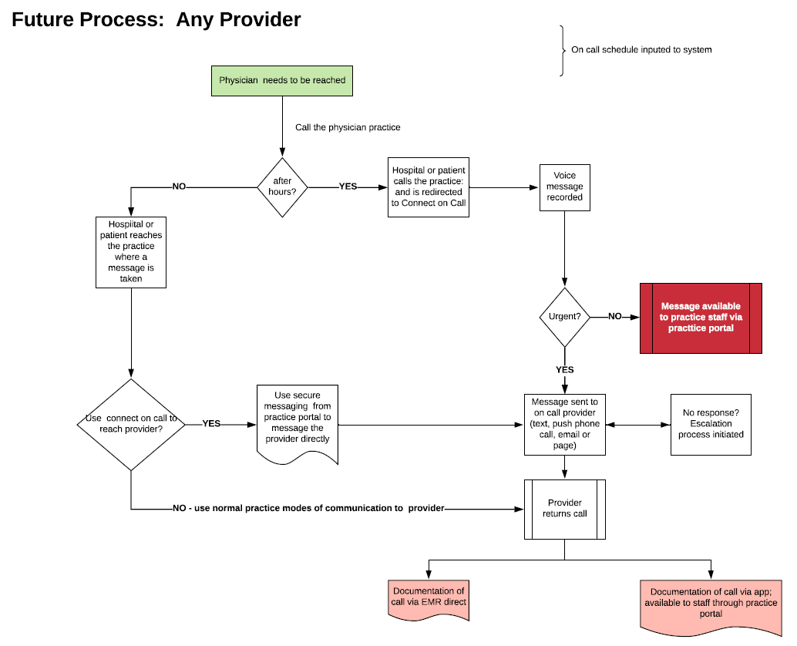

What number will patients or the hospital call if they want to get in touch with the provider on call?
If anyone wants to reach a provider using the system regardless if it is after hours, they will call that providers office. If it is after hours the calls will be forwarded to the connect on call system. If it is during business hours the calls will be answered by the practice front office staff. From there the practice can choose to either message the provider as they would normally do or use the Connect on Call messaging function.

How will this impact me if I take call for the hospital?
Most hospitals have never provided the switchboard service to outpatient providers. If the current arrangement with Munson never existed providers would have implemented a different system of being reached previously. This change represents an opportunity to create a smoother and more convenient way to manage after hours call that meet the needs of the patient and the providers. Changes to Munson’s processes are a result of the decision to eliminate switchboard functionality for non-employed providers.

I use the SPOK app now to get messages, how will this change if I start using Connect on Call?
Many workgroup members have weighed in on this during meetings. Providers can use two apps (SPOK and Connect on Call) to receive messages if that is what they chose to do. Many providers, however, want to consolidate to the use of Connect on Call to take advantage of the features of the system including the potential of billing to help offset costs.

I don’t want to use an app to get messages from my patients, how will this solution work for me?
Connect on Call will allow providers to dictate how messages are received and progressive escalation protocols if they are not reached initially. Messages can be set to be delivered through the app, via email, text or standardized telephone calls while all being delivered in a HIPAA compliant way. If a user elects to not use the app however they will not be able to maximize many of the benefits that the system has.

How do we (Munson, practices and NPO) plan to communicate this change to patients?
NPO and Munson have a meeting established on Friday May 24th, 2019 to discuss informing the community providers and general community. This level of discussion could only start once a vendor had been selected.

How is NPO coordinating this change with Munson?
NPO and Munson have a meeting established on Friday May 24th, 2019 to discuss informing the community providers and general community. This level of discussion could only start once a vendor had been selected

Cost:

What is the cost of the Connect on Call solution?

How will the practices be billed for the solution?
This is being investigated and will be updated as soon as more is known.

